The real truth
By Lorie Lacharité
Lorie Lacharité a first-year college student in human and social sciences at the CEGEP Garneau and sports is her passion.

E
ating disorders are a major problem in our society. It affects thousands of people around the world especially a select group of young ballet dancers in search of the perfect model to fulfill their dream of being thin. Driven by the pressures of dance teachers, parents and future employers, ballerinas feel a strong desire to be as thin as possible even if their body is unable to fallow. In their mind, this is the only way to be the best in their sports. These girls are six times more like to suffer from anorexia and other disease as the general population. Some people, despite the alarming facts, have continued to encourage excessive weight loss, but however, other people are trying to fight back.
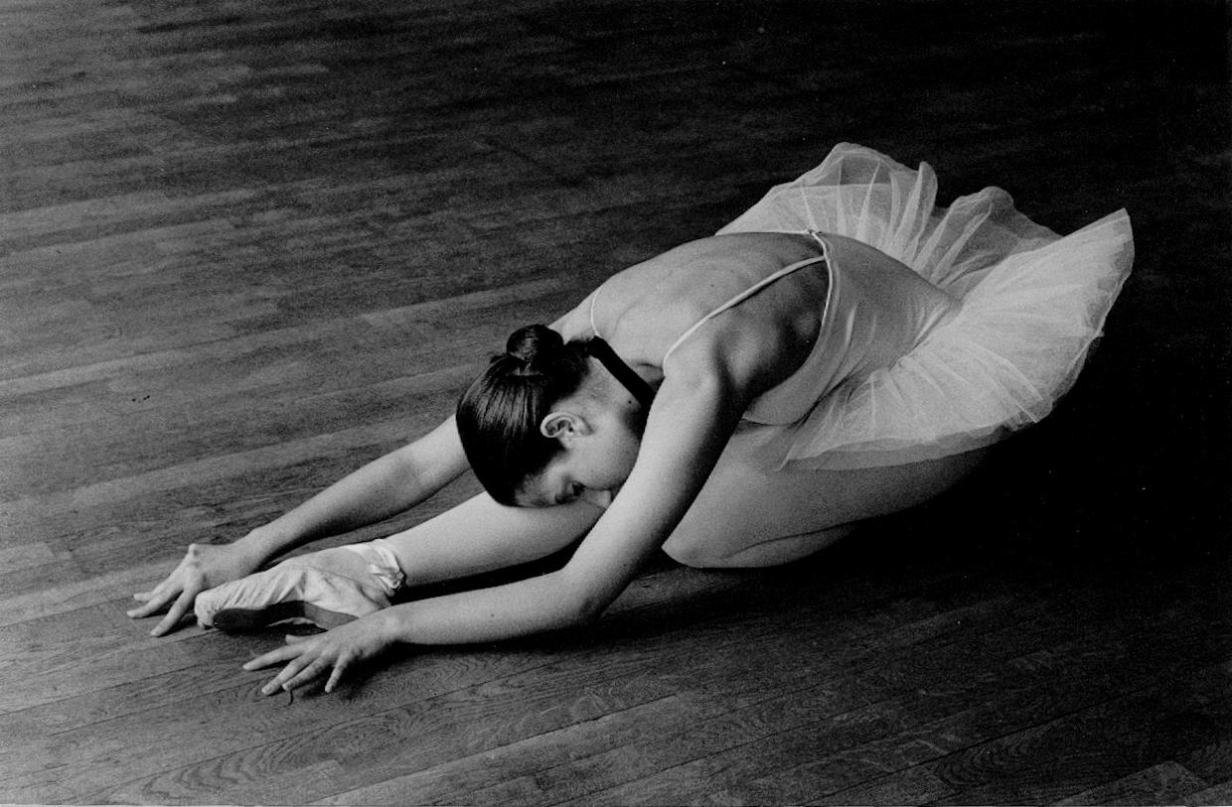
Indeed, according to Aparna Sharma, MD, who specializes in treating eating disorders at Loyola University Health System warns that the first cause of these eating disorders is granted to the perfect model that our society gives to be a good ballerina and encourage by companies. First of all, young girls in general and ballet dancers with eating disorders tend to be self-critical and sensitive. In addition, dance companies may be encouraging eating disorders and distorted body image by presuring dancers to be thin. Sharma adds that many dance companies require weigh-ins that could exacerbate the problem. Additionally, “Ballerinas are often plagued by perfectionism, social anxiety and pressures to be graceful and agile. This culture can push dancers to their physical limit and increase the risk for body image issues and eating disorders.” Extreme weight loss that is common can lead to fatigue, difficulty thinking, low blood pressure, rapid heart rate, seizures and stress fractures. Another example is Rachel Peppin, 42 years old, ex-principal dancer with BRB, who is suffering from anorexia. Peppin admits, “This must paint the worst picture”, as she recalls over-exercising, restricting her caloric intake and taking the occasional laxative. She noticed castings changed with more opportunities, and a review that complimented, “The incredible, waif-like Peppin.” She confesses, “I started to associate this extreme thinness with success.”Teachers encourage being as thin as possible. How is it acceptable in 2013?
“Must see the bones. Eat nothing.”
On the other hand, several awareness campaigns have been implemented to reduce the number of women with this disease. In Black Swan. The painfully thin image of ballerinas portrayed by Natalie Portman brings a focus to the negative side of dance that can lead to health risks from nutritional deprivation. In addition, in order to play this roll, the actress had to lose extreme weight that could have been dangerous. Dance companies and schools should conduct counseling and educational sessions on healthy eating and exercise habits mandatory for their students. Stress-reduction techniques, such as yoga and meditation, also provide valuable tools for young girls struggling with eating disorders. Early recognition and intervention can prevent co-morbidities, relapses and offer the best chance of successful treatment advises Dr. Aparna Sharma who specializes in eating disorders. In addition, the society organized a National Eating Disorders Week in February to sensibilize about this disease. The parents, teachers and dancers must be well informed.
Rachel Peppin
www.birminghammail.co.uk
To conclude, there are leaders and saboteurs of eating disorder, but the most important thing is to be aware and to be well informed of the consequences of this disease. It need to be acknowledges that there is a problem with eating disorders in ballet. Without this honesty and support, who is going to save them?
580 words

.

