Dance the disorders away
By Camille Fortin-Dupuis
Camille Fortin-Dupuis is a first-year Cegep student in literature and ballet dancer in her leisure time.

When you think of a ballet dancer, the image that comes to your mind is surely a doll-like ballerina, brushing against perfection. Well, dancers themselves often have this perception of what they should look like. This personal pressure, added to other external factors, can lead to an incontrollable stress, causing sometimes mental problems. Some studies actually showed that ballet dancers are more at risk of developing eating disorders than the general population. Dancing, as a sport and an art, should be a source of pleasure for youths and help them to let go; it should not create additional problems. This is why it is important to find solutions to deal with this issue.
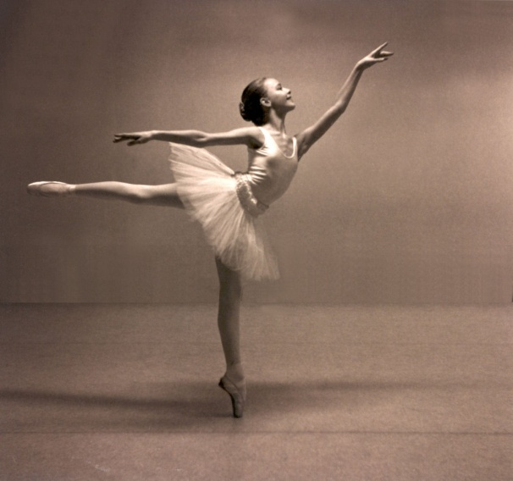 mayoyo.centerblog.net
Teach healthy habits
The first step to do to prevent such disorders among dancers – as in the population in general – is to teach them healthy habits. Having trainers who insist on the importance of thinness in ballet can lead young dancers to developing eating problems, without even realizing it. But, on the contrary, if dance leaders make them sensitive to the need of a good nutrition to perform in the sport and insist on this aspect, children will be positively influenced. I think that nutrition courses should be added to professional dancers training programs, as well as tips to learn how to handle the stress they have to live with.
Talk about it
A second way to forestall the problem spreading is to talk about it and to denounce it. For example, in 2012, Italian dancer Mariafrancesca Garritano was fired of La Scala Ballet Company because she publicly accused her teachers of promoting the extreme loss of weight among the dancers. According to me, the movie Black Swan, released in 2010, has been the beginning of the wave of denouncing what had not been admitted for so long. These public affirmations help dancers and ordinary people to realize the importance of the problem.
In brief, to prevent eating disorders in dance companies should integrate new techniques of teaching how to have a healthy look, and eating problems should not stay a taboo among dancers. But for anybody, self-confidence is primordial to eliminate such problems, so if you know someone who is at risk of developing an eating disorder, be sure they get help. After all, it is more beneficial to have a healthy life than to deny yourself nutrition, dancer or not.
409 words

